CERTIFICATE OF DELIVERY

DATE | 08/01/2026
EQUIPMENT | CW tester

PHOTO | ITEM | CANT
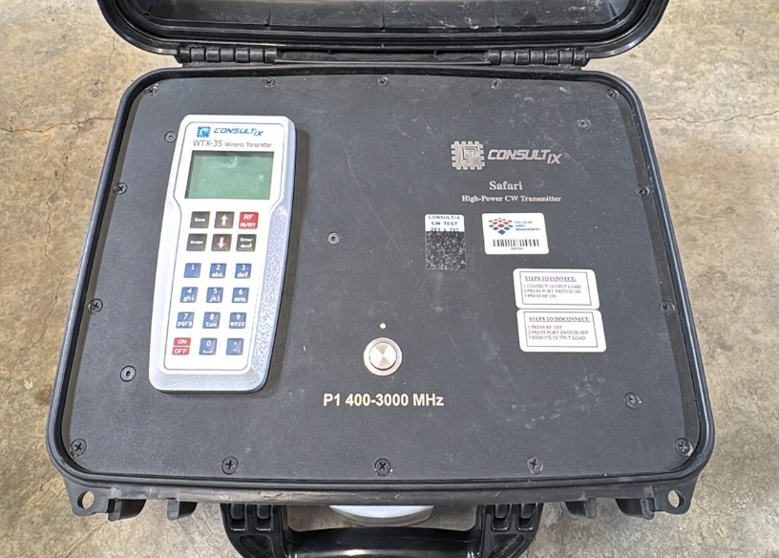 | High Power Kit  Safari Consultix  C1907SB111392 | 1
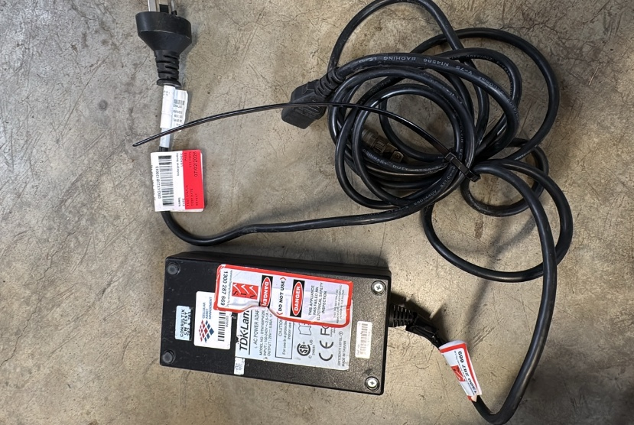 | Ac Power Suply  DTM165PW280 | 1

COMMENT:

